**Germany Certificate Attestation Services in the UAE with Prime Global Attestation**

Germany certificate [**attestation services in abu dhabi**](https://attestglobal.com/) is a critical step for individuals and businesses seeking to validate their documents for use in the UAE. Whether it's for employment, higher education, visa applications, or business purposes, attestation ensures your German-issued certificates are recognized by UAE authorities. **Prime Global Attestation** is a trusted partner in managing the attestation process with expertise and efficiency.

**Why Germany Certificate Attestation is Necessary**

[**Attestation services in abu dhabi**](https://attestglobal.com/) verifies the authenticity of your German documents, ensuring they comply with UAE regulations. Without attestation, your documents may not be accepted by government bodies, employers, or educational institutions in the UAE.

**Types of Certificates Attested by Prime Global Attestation**

1. **Educational Certificates**: Degrees, diplomas, and transcripts.
2. **Personal Documents**: Birth, marriage, and death certificates.
3. **Commercial Documents**: Power of attorney, business licenses, and agreements.

**The Attestation Process**

Prime Global [**Attestation services in abu dhabi**](https://attestglobal.com/) handles every step of the process, including:

1. **Notarization in Germany**: Documents are first verified by a German notary.
2. **Authentication by German Authorities**: The relevant state office validates the documents.
3. **German Ministry of Foreign Affairs (MOFA)**: Certification by the German MOFA.
4. **UAE Embassy in Germany**: Documents are attested by the UAE embassy in Germany.
5. **MOFA Attestation in UAE**: The final step ensures the documents are accepted within the UAE.

**Why Choose Prime Global Attestation?**

* **Expertise**: Years of experience in handling German document attestation.
* **End-to-End Support**: From document collection to final delivery, all steps are managed seamlessly.
* **Time-Saving**: Their team ensures a quick turnaround time.
* **Transparency**: Regular updates throughout the attestation process.

For a hassle-free and professional experience, trust **Prime Global Attestation** to manage your Germany certificate attestation needs in the UAE. Their expertise ensures your documents are processed quickly and accurately, giving you peace of mind.

Prime Global Attestation offers high-quality certificate attestation to US, UK, India, Saudi, Canada, Australia, China, France, Germany, Pakistan, Oman, Qatar & 140 + Countries for a wide range of documents, including birth certificates, marriage certificates, educational certificates, business certificates, powers of attorney, degrees, and commercial documents. We also offer translation and legalization services for family visas for private individuals, public organizations, and private businesses.

**Mob: +971 569986516**

**For any query, please visit our site:** [**https://www.attestglobal.com**](https://www.attestglobal.com)

**For more details information,** [**Attestation services in Abu Dhabi**](https://www.attestglobal.com)**,** [**Attestation services in UAE**](https://www.attestglobal.com/)**,** [**Attestation services in Dubai**](https://www.attestglobal.com)**,** [**attestation services in sharjah**](https://www.attestglobal.com)

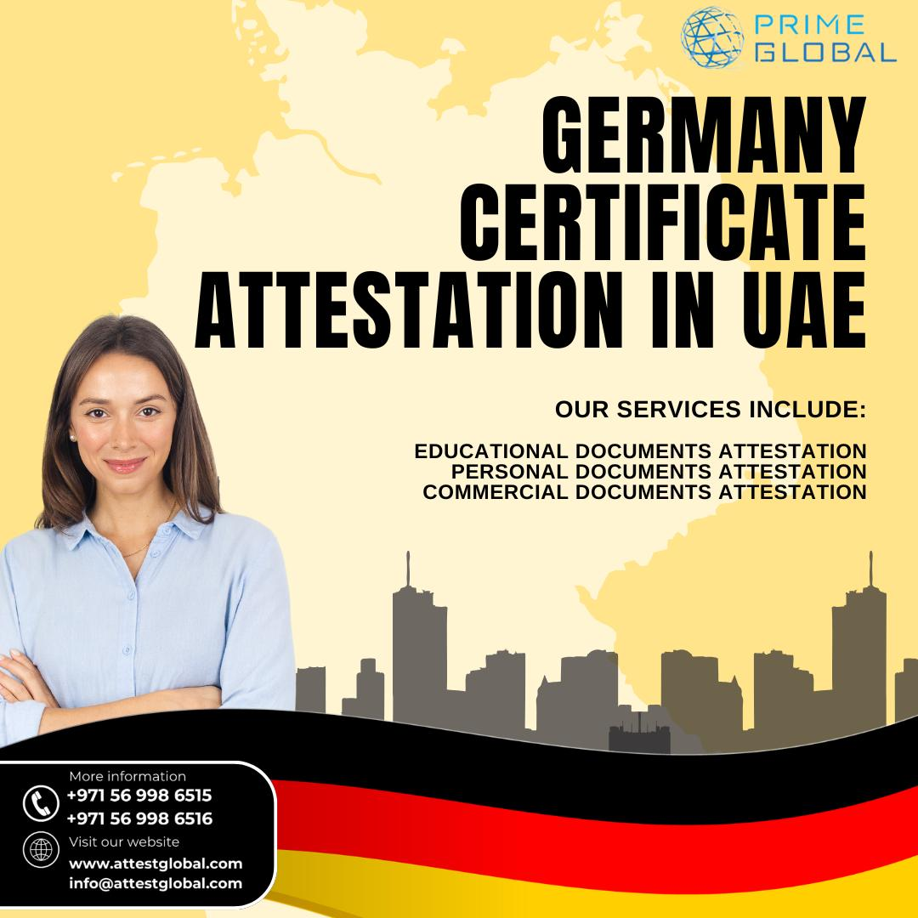Bottom of Form